Great trade for Red & White Holsteins on farm with 12 over £2,000

It was a cold, raw November day at Bolton Peel Farm, Sawley on Saturday but the big crowd of buyers and the red hot trade kept the chill away. Messrs Huyton decided after 30 years in dairy farming to sell the herd and concentrate on their haulage & contracting businesses. The herd was a top quality unit of blended red & white Holsteins, descended from Ayrshires. Management was strictly commercial with the cows winter housed on straw yards.

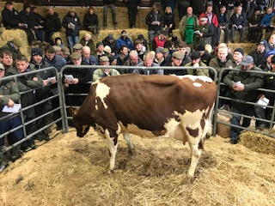

The event attracted 47 buyers from as far afield as Worcestershire, Leicestershire & Dumfries as well as from all parts of the North of England. There were several strong bidders and the principal buyer was the Myerscough College from Bilsborrow, Preston who took a load of 35 including several of the best cows. They claimed the top priced animal of the day being a fresh calved daughter of Denmire Feature Red, giving 30kg in her second lactation. She made 2,400 guineas. Denmire bulls had bred exceptionally well in the herd and another ‘Feature’ daughter fetched 2,250 to the same buyers having calved her second in late August and giving 35kg daily.Denmire Feature also sired the third highest price at 2,100gns for a one week fresh young cow giving 33kg.

Kevin Lupton, who always has a keen eye for a good one paid 2,100 guineas for a Denmire Marius daughter 2 ½ months calved giving 35kg

Served heifers seemed a sound trade but good value in several cases and peaked at 1,450 guineas for another Denmire Feature daughter. Young stock were in very strong demand with calves at foot averaging £566, up to 610 gns and maiden heifers peaking at 1,100 gns with 9 making 900 guineas or more.

AVERAGES: 116 Cows & Calved Heifers avg. £1,420.03
25 Served Heifers (pd+) avg. £1,237.32
17 Recently Served Heifers avg. £ 922.14
36 Maiden Heifers avg. £ 826.00
194 Lots (inc 8 calves @£566) avg. £1,242.62
9 3 Qrtrd Cows avg. £852.83

Auctioneers: NORTON & BROOKSBANK
Guest auctioneer: FRED SPURGEON

